Mr. Catering
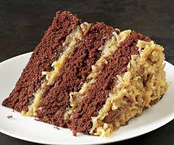  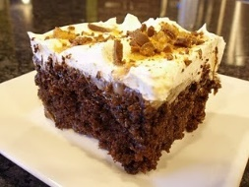 |  | German Chocolate $35  Delicious moist chocolate cake with a caramel coconut custard frosting to even make heaven better. Heavenly, moist, and rich in flavor. Punch Bowl Cake $38  Not only for casual events at a picnic but formal as well. Consisting of lemon cake, fruit, custard, and rich cream. An savory & deductible “cannot just have one serving”  “Better than Sex” $40  The Titles says it all, however the nuns love it.  “Sour Cream Pound Cake” $27  Rich, Buttery, Creamy, Lemony Flavor.  [Menu Item Name]  [Menu item description.]

Variety of Cakes:
Our cake are offer in 3- layer cakes, cupcakes, or any desired format. For
These prices I haves selected, your receiving Savory and Southern quality Baking.
Underlined cakes are our Specialties

- Angel Food Cake $30
- Carrot Cake $35
- Strawberry Shortcake $30
- Coconut Cream Cake$38
- Chocolate Chiffon Cake$37
- Butter Pound Cake$35
- Orange Pound Cake$35
- Red Velvet $40
- Almond Pink Cake $30
- Caramel Coconut Cake $38
- Chocolate Toffee Cake $38
- Auburn Cake$40
- Alabama Cake$40
- Rich Chocolate Cake$35
- Lemon Frost Cake$35
- Pineapple Creamcake$25
- Pineapple Upside Down Layer Cake $35
- Chocolate Pound Cake $35
- Double Chocolate Cake $30
- German Chocolate Cake $ 35
- Punch Bowl $38
- “Better Than Sex Cake” $40
- Sour Cream Pound Cake $27

